**Azure Monitoring Infra health check**

1. Sign in to Azure Portal
2. Go to Azure service health

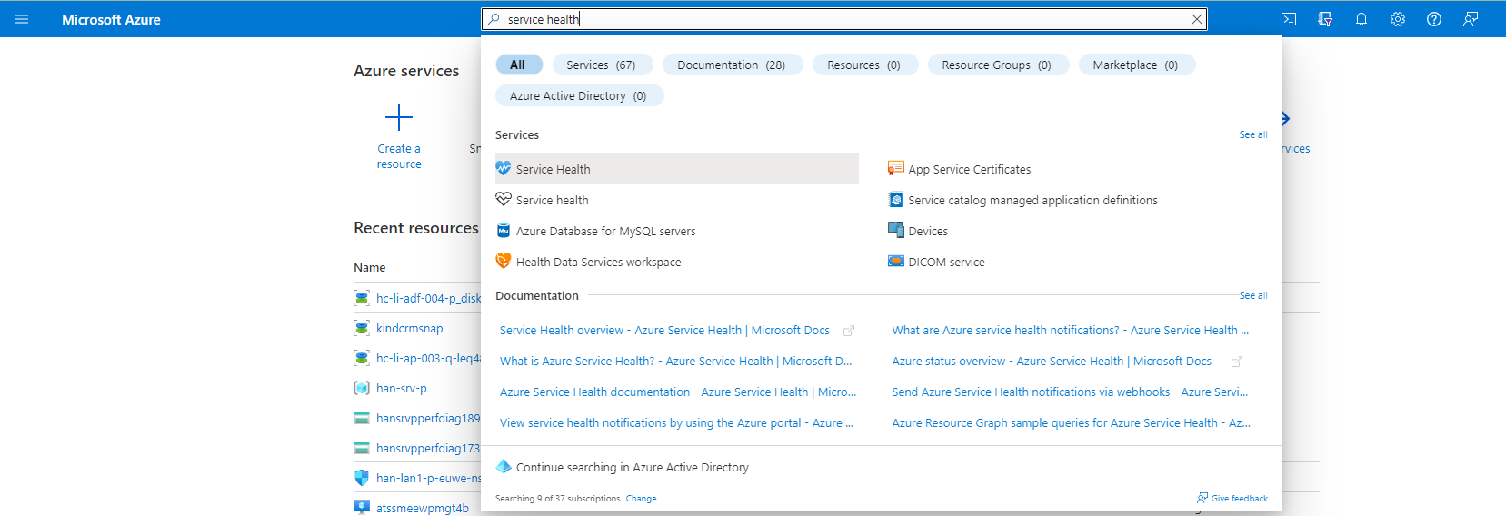

1. Check if any issue on any service is undergoing. Find root cause and planned maintenance window as well.

